[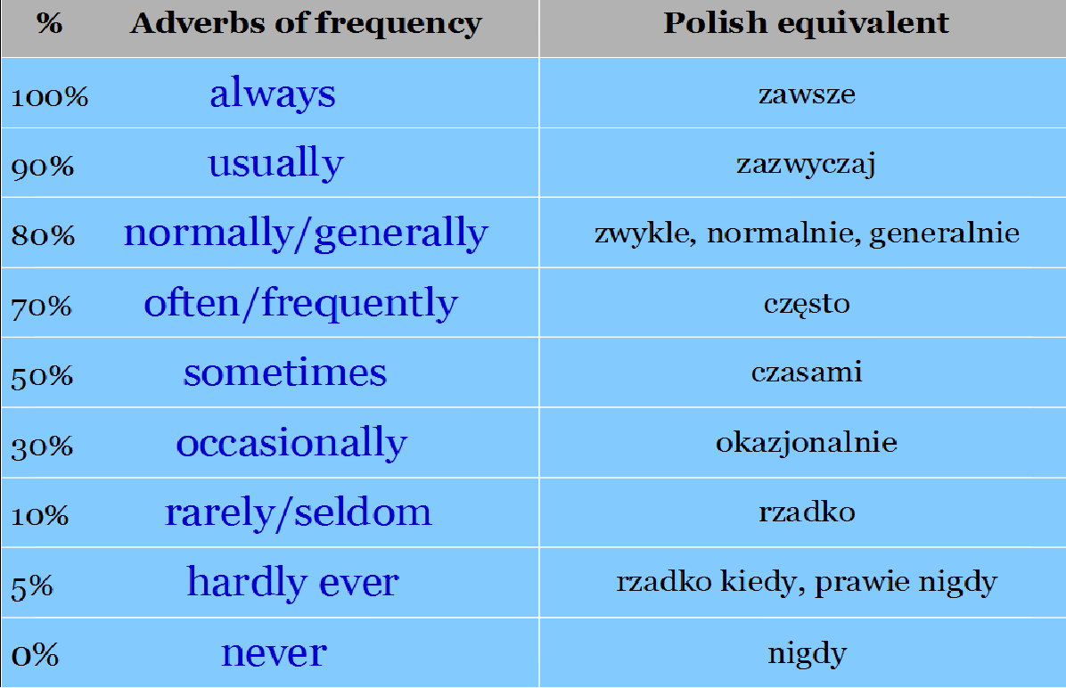](https://www.google.pl/url?sa=i&url=http%3A%2F%2Fwww.wheninbritain.com%2F2015%2F05%2Fadverbs-of-frequency.html&psig=AOvVaw0U3tC7d8_p7b6aOAdg6Vfd&ust=1586242524143000&source=images&cd=vfe&ved=0CAIQjRxqFwoTCMj4q4Kc0-gCFQAAAAAdAAAAABAp)