J. angielski – 3, 4 latki
Propozycje zadań

- Piosenka na powitanie
https://supersimple.com/song/whats-your-name/
Hello, Hello, What’s your name?
Hello, Hello, What’s your name?
My name is Noodle.
My name is Blossom.
Nice to meet you.
Hello, Hello, What’s your name?
Hello, Hello, What’s your name?
My name is Cheesy.
My name is Broccoli.
Nice to meet you.
Hello, Hello, What’s your name?
Hello, Hello, What’s your name?
My name is Jelly.
My name is Kernel.
Nice to meet you!
Let’s be friends!

- Piosenka o pogodzie
https://supersimple.com/song/hows-the-weather/
How’s the weather? How’s the weather?
How’s the weather today?
Is it sunny?
Is it rainy?
Is it cloudy?
Is it snowy?
How’s the weather today?
Let’s look outside.
How’s the weather?
Is it sunny today?
Let’s look outside.
How’s the weather?
Is it rainy today?
Let’s look outside.
How’s the weather?
Is it cloudy today?
- Pokoloruj obrazki z pogodą. Określ jaka jest pogoda na danym obrazku/Wskaż odpowiedni obrazek.

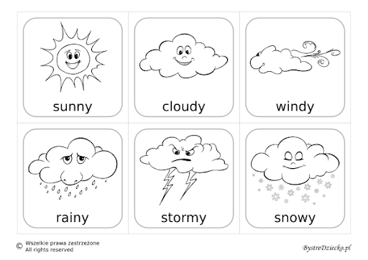

4. Piosenka na pożegnanie
https://www.youtube.com/watch?v=0LDArAJf7-c

