Vocabulary

Crime verbs
arrest a suspect be guilty be innocent catch a thief commit a crime do community service go on trial go to prison investigate a crime
look for clues pay a fine question a suspect solve a crime suspect someone

Podkreśl właściwe słowa.
solve / catch a crime 1 pay / arrest a suspect 2 look for / solve clues 3 go / do on trial
  - be / do community service
  - make / commit a crime
  - do / be innocent
  - pay / do a fine

Dopasuj obrazki do wyrażeń.
- Uzupełnij zdania wyrazami Criminals lub
The police.
The police arrest a suspect.
- are guilty.
- commit crimes.
- go to prison.
- look for clues.
- question a suspect.
- do community service.

4 Wybierz właściwe słowa do uzupełnienia luk.

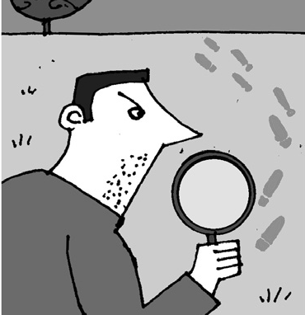
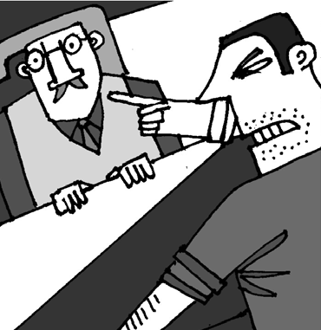
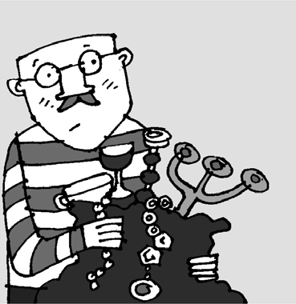
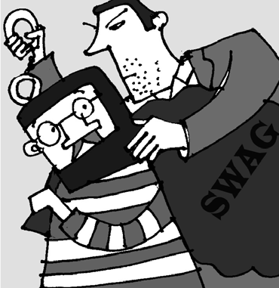
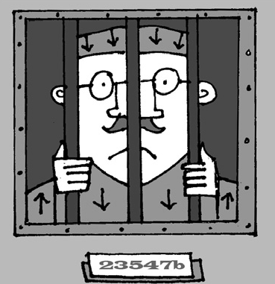
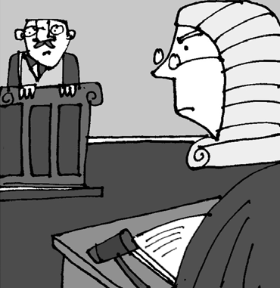
a b
€10,000 STOLEN FROM JACK’S RESTAURANT
€10,000 was taken from Jack’s Restaurant last night. The police are investigating this serious … . They are

 |  | looking for (1)… and they are questioning (2)… . The police hope to arrest the (3)… later today. Detective Watkins says: ‘This is very serious. We expect to solve the (4)… very soon and this thief will go to (5)… for
c | d several years.’  - crime b) suspect  1 a) fines b) clues
e | - a) suspects b) guilty  - a) thief b) crime  - a) crime b) trial  f 5 a) trial b) prison
1 be guilty | d
- go on trial
- investigate a crime
- catch a thief
- go to prison
- question a suspect

Crimes and criminals
kidnapping murder pickpocketing robbery theft vandalism kidnapper murderer pickpocket robber thief vandal

- Znajdź trzy nazwy zbrodni i trzy nazwy kryminalistów w diagramie.

V | Z | T | E | K | C | O | P | K | C | I | P
X | R | E | K | I | R | B | Y | H | I | G | U
R | E | T | Z | D | R | Y | N | T | Z | P | E
E | D | F | N | N | U | E | V | I | L | C | G
B | R | E | S | A | E | D | G | U | R | D | O
B | U | H | S | P | D | U | G | R | F | R | O
O | M | T | O | P | A | C | N | I | O | F | H
R | E | T | F | I | L | P | O | H | S | F | P
J | L | V | A | N | D | A | L | A | S | C | O
R | E | L | F | G | U | M | S | F | N | G | T
U | G | V | U | Z | S | G | F | V | L | C | L
L | U | U | D | U | Q | T | A | H | D | E | O
- Uzupełnij tabelkę.

Crime  (1) vandalism | Criminal  vandal
robbery | (2)
(3) | murderer
pickpocketing | (4)
(5) | kidnapper
(6) | thief
- Przeczytaj definicje I wybierz odpowiednie słowa.
killing people
murder / vandalism 1 stealing things

theft / kidnapping
  - a person who steals things from someone’s pocket

vandal / pickpocket
  - a person who steals things from someone’s house

robber / murderer
  - taking someone away from their family to get money in return

pickpocketing / kidnapping
  - damaging things on public property

robbery / vandalism
- Nazwij przestępców. Wybierz wyrazy z ramki.
kidnapper murderer pickpocket robber thief vandal
When I got home I found that the TV, computer and my mp3 player had gone. robber
- The family got a letter asking for 12 million euros.
- He painted on the walls and threw
paint over the chairs.
- I realized he had stolen my wallet
when I got home.
- He took all the money from the
shop before the police arrived.
- He left the dead body there for
two days.

